Paintworks SQL Server Express Log Database Configuration

This document addresses the configuration of SQL Server Express 2005 databases used for Paintworks Alarm, Change and Production logs.

Recently, errors have occurred when the PW_Maint application attempted to delete old records in log databases. Investigation into these errors showed that they are caused by two problems in the Paintworks SQL Server databases.

1.) Improper database configuration that caused the transaction log files to fill up to the point that no records could be deleted from the databases because there was no room in them to log the new transactions.

2.) The omission of code in the Stored Procedures that are used to delete expired records to shrink the transaction logs. This problem allowed the log files to grow until they reached their size limits.

Database Transaction Log Configuration

Transaction log files (.ldf files) for the Alarm Log, Changelog, and Production Log databases need to be configured to enable Autogrowth with File Growth set to In Percent (by 10%) and the Maximum File Size set to Unrestricted File Growth to prevent them from filling up. This is done using Microsoft SQL Server Managegement Studio Express. The procedure that must be followed for each of the Paintworks Alarm Log, Changelog, and Production Log databases is as follows:

1.) Expand the Databases folder in the Object Explorer tree view. Right-click on the database name and select Properties from the context menu. The following screen will appear.

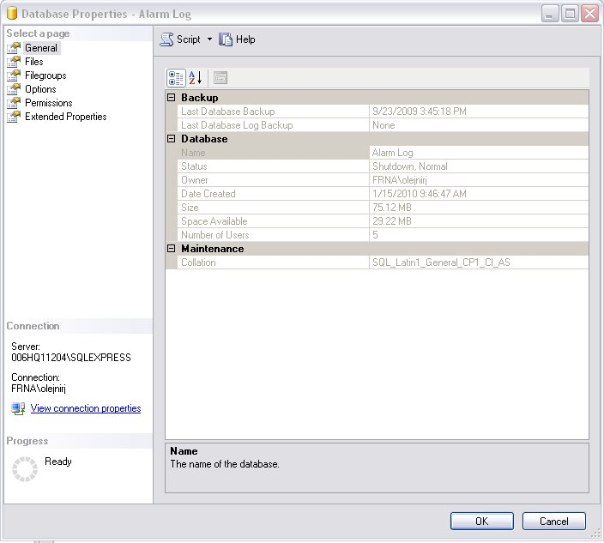

2.) Select the Files Page. Then click the button (shown outlined in red below) in the Autogrowth column for the transaction log file.

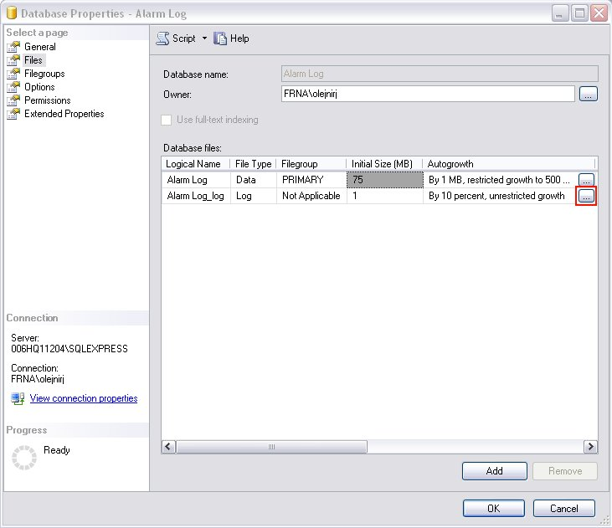

3.) The screen (below) will be shown. Select the settings shown below then click OK.

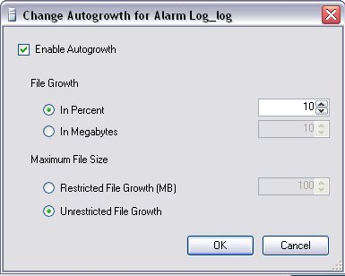
DeleteOldRecords Stored Procedures

Stored procedures are used to delete expired records from the Paintworks Alarm Log, Changelog and Production Log databases. The initial versions of these procedures did not always include provisions to shrink the database tables or the transaction log files. These instructions must be added to the current stored procedures to allow them to properly maintain the database files. The Alarm Log dbo.DeleteOldRecords stored procedure is used as an example below, however the DeleteOldRecords stored procedures foe the Changelog and Production Log databases must be modified in a similar manner. This is also done using Microsoft SQL Server Managegement Studio Express. The procedure is as follows:

1.) Expand the Object explorer tree view to show the list of stored procedures for the selected database as shown in the picture below.

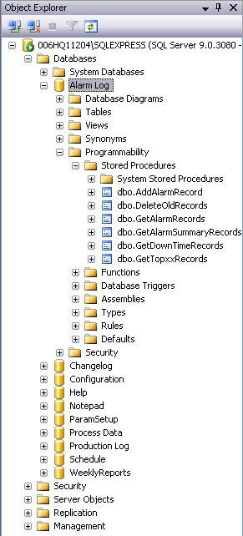

2). Right-click dbo.DeleteOldRecords and then select Modify from the context menu. The screen shown below will appear. The code outlined in red will either not exist or will be incorrect in the current stored procedures. Change the code as shown below for the Alarm Log stored procedure.

For the Changelog dbo.DeleteOldRecords stored procedure, these two lines will read:

DBCC SHRINKDATABASE ([ChangeLog], 10);
DBCC SHRINKFILE ([ChangeLog_Log], 10);

For the Production Log dbo.DeleteOldRecords stored procedure, these two lines will read:

DBCC SHRINKDATABASE ([Production Log], 10);
DBCC SHRINKFILE ([Production Log_Log], 10);

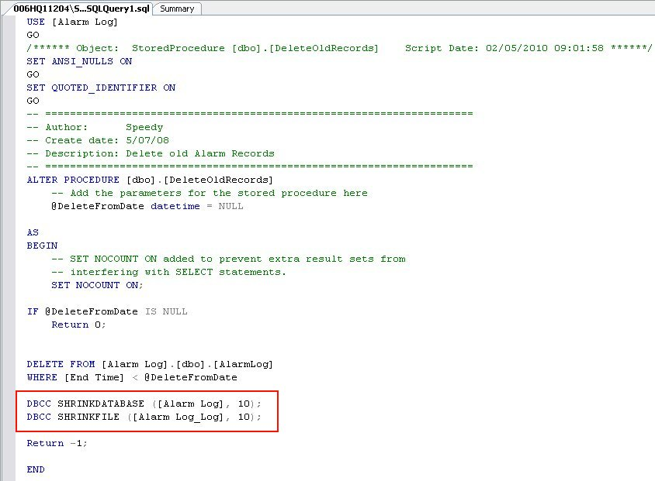

3.) To save your changes, select Execute from the Query menu as shown in the picture below. You will receive a message on the lower portion of the screen to indicate that the query executed successfully. This indicates that your changes have been saved.

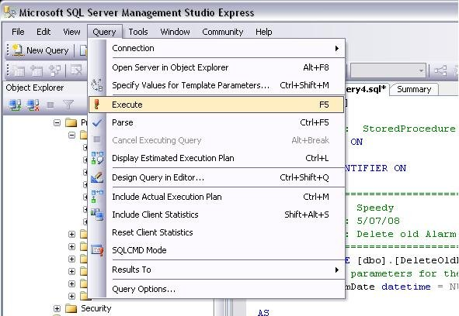

4.) When you attempt to close the tab where the code for the stored procedure appears, you will be asked if you want to save your changes. Click No because this function just saves it off to a text file. The changes you made are stored in the database by executing the query. You can verify that the changes you made have been saved by Right-clicking dbo.DeleteOldRecords and then selecting Modify from the context menu to show the code again.

